Part 1: TITLE, AUTHORS, APPROVALS, etc

Code assigned: | 2023.061B

Short title: To create one genus, Septuagintavirus, containing two species in the subfamily Vequintavirinae

Author(s) and email address(es)
Buttimer C, Cortes-Martin A, Kropinski A, Turner D, Draper L-A, Ross R-P, Hill C | colin.buttimer@ucc.ie; acortesmartin@ucc.ie; phage.canada@gmail.com; Dann2.Turner@uwe.ac.uk; l.draper@ucc.ie, p.ross@ucc.ie; c.hill@ucc.ie
Author(s) institutional address(es) (optional)
Biosciences Building, University College Cork, Ireland [CB, CMA, RPR, CH]
Departments of Pathobiology, University of Guelph, Guelph, Ontario, Canada [AK]
Department of Applied Sciences, University of the West of England, Bristol, UK [DT]

Corresponding author
Buttimer, C
List the ICTV Study Group(s) that have seen this proposal
Caudoviricetes study group

ICTV Study Group comments and response of proposer

ICTV Study Group votes on proposal

Study Group | Number of members
 | Votes support | Votes against | No vote
Authority to use the name of a living person

Is any taxon name used here derived from that of a living person (Y/N) | N

Taxon name | Person from whom the name is derived | Permission attached (Y/N)

Submission dates
Date first submitted to SC Chair | April 2023
Date of this revision (if different to above)
ICTV-EC comments and response of the proposer

Part 2: NON-TAXONOMIC PROPOSAL
Text of proposal

Part 3: TAXONOMIC PROPOSAL
Name of accompanying Excel module
2023.061B.N.v1.Septuagintavirus_ng.xlsx
Abstract

Here, we propose the creation of a new genus, "Septuagintavirus", comprising two new species within the subfamily of Vequintavirinae. This proposal is based on genomic-based comparisons.

Text of proposal

Supporting evidence

Source of the names used for taxa:
Septuagintavirus: The name of the genus is derived from the name given to the first example of this phage isolated, namely Escherichia phage W70 [1].

Species demarcation criteria:
In this proposal, we have chosen 95% DNA sequence identity/similarity as the criterion for the demarcation of a species. Each proposed species genome differs by more than 5% in nucleotide identity/similarity as determined by the BLASTN algorithm and VIRIDIC (Table 1, Figure 2) [2, 3]. As a result, Escherichia phages W70 (accession no. OP778610) and A7_1 (accession no. OP795442) are classed as strains of phages A73 and A5_4, respectively (Figure 2, Table 1). We have chosen phage A73 over phage W70 to represent one of the two proposed species of this genus due to its larger genome size.

Genus demarcation criteria:
Phylogenetic analysis indicates that phages Escherichia phages W73 and A5_4 represent species that form a cohesive and distinct genus within the subfamily Vequintavirinae (Table 1, Figures 2 & 3). Selected genomes of phages representing this genus range from 142 to 145 kbp, encoding between 264 to 276 proteins with five tRNA genes. Gene synteny of these phages is most conserved with phages of the genus Certrevirus within the subfamily Vequintavirinae (Figure 4).

Transmission electron microscopy shows that phage W70 possesses a myovirus A1 morphotype (Figure 1) [4]. The phage possesses an icosahedral head (68.65 ± 3 nm in diameter, n = 12), with clearly distinguishable hexagonal outlines, and a contractile tail (120.36 ± 4.12 nm × 25.39 nm, n = 12), possessing a bundle of thin and flexible tail fibres.

History:
The phages A73 and A5_4, representing the species forming the proposed genus of Septuagintavirus were isolated from samples taken from an animal farm in Co. Cork, Ireland [1].
.
Electron micrograph:
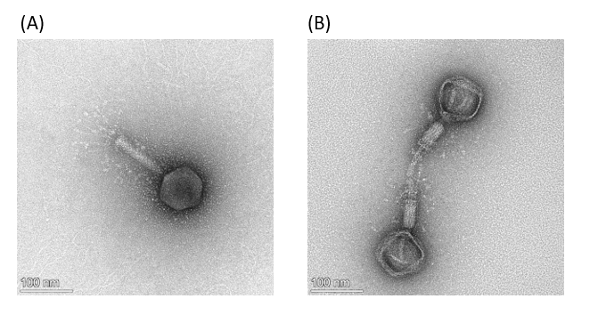
Figure 1. Transmission electron micrographs of Escherichia phage W70 stained with 2% (w/v) uranyl acetate. (A) Uncontracted phage W70 virion particle and (B) two particles with empty capsids and contracted tail sheath. The scale bar represents 100 nm.

GenBank Summary:
Table 1. Properties of the two phages representing the species belonging to the genus "Septuagintavirus"

Phage | INSDC accession number | Genome size (bp) | Number of ORFs | Number of tRNA genes | GC content (%) | Nucleotide homology (%)* | Homologous Proteins (%)**
A73 | OP778609 | 142,009 | 264 | 5 | 41 | 100 | 100
A5_4 | OP744025 | 145,365 | 276 | 5 | 41 | 93 | 93
* Determined using BLASTN [3]; ** Determined using CoreGenes 5 [5]

Phylogeny:

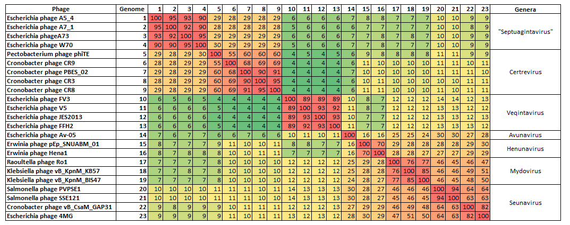
Figure 2. Heatmap showing nucleotide similarity of Escherichia phages isolated in this study and other members of the subfamily Vequintavirinae as calculated with VIRIDIC [2].

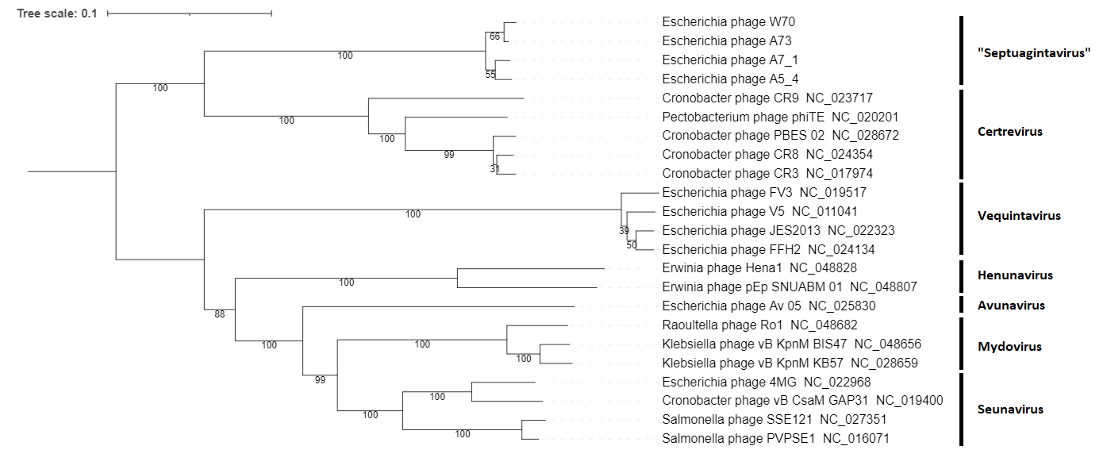
Figure 3. Amino acid VICTOR-generated phylogenomic Genome-BLAST Distance Phylogeny (GBDP) tree was inferred using the formula D4 and yielded average support of 86% [6]. The phylogram includes the Escherichia phages isolated in this study and other members of the subfamily Vequintavirinae. The genus (if allocated) of phages in the analysis is illustrated. Branch support was inferred from 100 pseudo-bootstrap replicates.
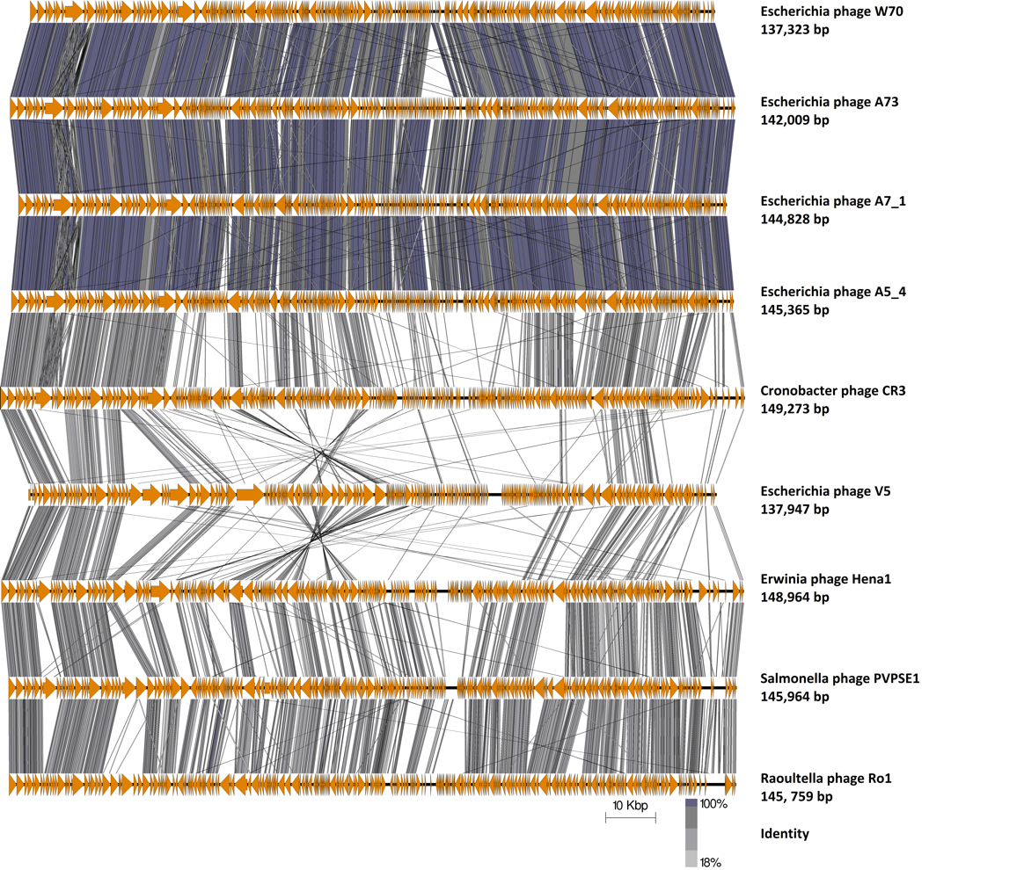
Figure 4. Genome map comparison of the genomes of Escherichia phages isolated in this study and other members of the subfamily Vequintavirinae employing TBLASTX and visualisation with Easyfig [7]. The genome maps display arrows indicating the locations and orientation of ORFs among different phage genomes. The large terminase was set as the first gene among all genomes.

References
1. Cortes Martins A, Buttimer C, F H, et al Isolation and characterisation of novel phages of Escherichia coli representing a new genera of the subfamily Vequintavirinae
2. Moraru C, Varsani A, Kropinski AM (2020) VIRIDIC—A Novel Tool to Calculate the Intergenomic Similarities of Prokaryote-Infecting Viruses. Viruses 2020, Vol 12, Page 1268 12:1268. https://doi.org/10.3390/V12111268
3. Altschul SF, Gish W, Miller W, et al (1990) Basic local alignment search tool. J Mol Biol 215:. https://doi.org/10.1016/S0022-2836(05)80360-2
4. Ackermann HW (2001) Frequency of morphological phage descriptions in the year 2000. Brief review. Arch Virol 146:843–57
5. Turner D, Reynolds D, Seto D, Mahadevan P (2013) CoreGenes3.5: a webserver for the determination of core genes from sets of viral and small bacterial genomes. BMC Res Notes 6:140. https://doi.org/10.1186/1756-0500-6-140
6. Meier-Kolthoff JP, Göker M (2017) VICTOR: genome-based phylogeny and classification of prokaryotic viruses. Bioinformatics 33:3396–3404. https://doi.org/10.1093/bioinformatics/btx440
7. Sullivan MJJ, Petty NKK, Beatson SAA (2011) Easyfig: a genome comparison visualizer. Bioinformatics 27:1009–1010. https://doi.org/10.1093/bioinformatics/btr039
8. O'Leary NA, Wright MW, Brister JR, Ciufo S, Haddad D, McVeigh R, et al. Reference sequence (RefSeq) database at NCBI: current status, taxonomic expansion, and functional annotation. Nucleic Acids Res. 2016;44(D1):D733-45. doi: 10.1093/nar/gkv1189. PMID: 26553804.
9. Sayers EW, Beck J, Bolton EE, Bourexis D, Brister JR, Canese K, Comeau DC, Funk K, Kim S, Klimke W, Marchler-Bauer A, Landrum M, Lathrop S, Lu Z, Madden TL, O'Leary N, Phan L, Rangwala SH, Schneider VA, Skripchenko Y, Wang J, Ye J, Trawick BW, Pruitt KD, Sherry ST. Database resources of the National Center for Biotechnology Information. Nucleic Acids Res. 2021 Jan 8;49(D1):D10-D17. doi: 10.1093/nar/gkaa892. PMID: 33095870

